Appendix – Bulding a Dominator Tree

1. Definitions
We define a Rooted Food Web as a directed graph (digraph) composed by N nodes linked by E directed edges. N-1 nodes represent the trophospecies, while the remaining node is the root of the food web (external environment), a special node that has in-degree (number of incoming edges)=0.
The digraph is connected, that is to say there exists at least a sequence of nodes and edges (path) connecting the root to any other node.
Node a is a dominator of node b (a=dom(b)) if every path from root r to b contains a: that is to say, a quantum of matter entering into the system can not reach b without visiting a.
From this definition we can state that:
- all nodes are dominated by root r;
- every node dominates itself;
- a proper dominator of node b is every node z satisfying properties z=dom(b); z≠b;
If we interpret this concept ecologically, a dominator is a node that acts as a bottleneck in energy matter distribution, being an obliged step in the path from r (external environment) to dominated nodes.
2. Building a dominator tree
Let’s consider the graph in Figure 1., which represents simplified dynamics of lake Findley (adapted from Richey et al. 1978).
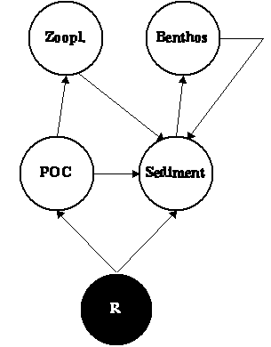
Figure 1. Sample Food Web.
The adjacency matrix (a NxN matrix where coefficients are 1 when there is an edge from row to column, 0 elsewhere) associated will be:
 | R | Sediment | POC | Benthos | Zooplankton
R | 0 | 1 | 1 | 0 | 0
Sediment | 0 | 0 | 0 | 1 | 0
POC | 0 | 1 | 0 | 0 | 1
Benthos | 0 | 1 | 0 | 0 | 0
Zooplankton | 0 | 1 | 0 | 0 | 0

There are many algorithms that find dominators. Here we summarize the one presented by Aho et al. (1986) because is the easiest one.
The first step requires one to build a matrix that will contain dominators, the so-called Dominator Matrix (DM from here). When we initialize it, all the coefficients will be 1 except the ones of the first line (root), where we will set all coefficients to zero but the first one that will be 1:
DM | R | Sediment | POC | Benthos | Zooplankton
R | 1 | 0 | 0 | 0 | 0
Sediment | 1 | 1 | 1 | 1 | 1
POC | 1 | 1 | 1 | 1 | 1
Benthos | 1 | 1 | 1 | 1 | 1
Zooplankton | 1 | 1 | 1 | 1 | 1

Once the dominator matrix has been obtained, one should start comparing the rows of the matrix.
The comparison is carried out with two operations: union ∪ and intersection ∩.
In this case we define these two operations among DM rows as:
- Union → If two corresponding coefficients are equal assign the same coefficient to the result, else assign 1. This operation corresponds to the OR BITWISE command of many programming languages.
- Intersection → multiply corresponding coefficients to obtain the result. This operation corresponds to the AND BITWISE command of many programming languages.
e.g.
1 | 0 | 1 | 0 | 1 | 0 | 1 |  |  |  | 1 | 0 | 1 | 0 | 1 | 0 | 1 | 
1 | 1 | 1 | 0 | 0 | 0 | 1 | = |  |  | 1 | 1 | 1 | 0 | 0 | 0 | 1 | =
1 | 1 | 1 | 0 | 1 | 0 | 1 |  |  |  | 1 | 0 | 1 | 0 | 0 | 0 | 1

For each node x excluding the root we should assigns dominators as:
dom(x)={x}∪{dom(i1)∩ dom(i2) ∩ …∩ dom(ik)}
where i1,i2,…,ik are the nodes that points to node x.
Once we have carried out this comparison among all nodes we should check if any row of the DM matrix has changed: if there have been changes then we should repeat the procedure until we can do a whole pass without changes.
e.g.
Starting from the DM matrix above, the steps are:
1. dom(Sediment)={Sediment}∪ {dom(R)∩dom(POC)∩dom(Zoopl.)∩dom(Benthos)}
that, using DM rows, can be written as:
dom(Sediment) | = | 0 | 1 | 0 | 0 | 0 |  | { | 1 | 0 | 0 | 0 | 0 | 
 |  |  |  |  |  |  |  |  | 1 | 1 | 1 | 1 | 1 | 
 |  |  |  |  |  |  |  |  | 1 | 1 | 1 | 1 | 1 | 
 |  |  |  |  |  |  |  |  | 1 | 1 | 1 | 1 | 1 | }
That becomes:
dom(Sediment) | = | 0 | 1 | 0 | 0 | 0 |  | { | 1 | 0 | 0 | 0 | 0 | }
 | = | 1 | 1 | 0 | 0 | 0
We substitute the second row of DM matrix with the new values.
2. dom(POC)={POC}∪ {dom(R)}
dom(POC) | = | 0 | 0 | 1 | 0 | 0 |  | { | 1 | 0 | 0 | 0 | 0 | }
 | = | 1 | 0 | 1 | 0 | 0
This will be the third row of DM matrix.
3. dom(Benthos.)={Benthos.}∪ {dom(Sediment)}
dom(Benthos) | = | 0 | 0 | 0 | 1 | 0 |  | { | 1 | 1 | 0 | 0 | 0 | }
 | = | 1 | 1 | 0 | 1 | 0
(4th row)
4. dom(Zoopl.)={Zoopl.}∪ {dom(POC)}
dom(Zoopl.) | = | 0 | 0 | 0 | 0 | 1 |  | { | 1 | 0 | 1 | 0 | 0 | }
 | = | 1 | 0 | 1 | 0 | 1
(5th row)
After the first pass, the DM matrix has been changed to:
DM | R | Sediment | POC | Benthos | Zooplankton
R | 1 | 0 | 0 | 0 | 0
Sediment | 1 | 1 | 0 | 0 | 0
POC | 1 | 0 | 1 | 0 | 0
Benthos | 1 | 1 | 0 | 1 | 0
Zooplankton | 1 | 0 | 1 | 0 | 1

As the second pass would produce no changes, this is the definitive Dominator Matrix. In this matrix a coefficient 1 means that row-node dominates column one.
Using this matrix we can build the Dominator Tree by linking to any node a to its immediate dominator b, that is a node that shares all the dominators with a excluding a itself.
In this case R has no immediate dominator, while both Sediment and POC have R as immediate dominator and Benthos and Zooplankton have Sediment and POC respectively.
The resulting Dominator Tree is sketched in Figure 2.
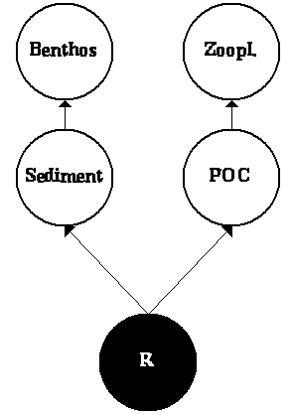
Figure 2. The Dominator Tree of the food web presented in Figure 1.
The procedure described above can be easily implemented in any programming language, as one cannot calculate the dominator tree of a 100 nodes food web without computer aid.
To obtain a complete source code performing dominator trees send an e-mail to Stefano Allesina (sallesina@nemo.unipr.it).

Literature Cited

J.E. Richey, R.C. Wissmar, A.H. Devol, G.E. Likens, J.S. Eaton, R.G. Wetzel, W.E. Odum, N.M. Johnson, O.L. Loucks, R.T. Prentki and P.H. Rich , Carbon flow in four lake ecosystems: a structural approach. Science 202 (1978), pp. 1183–1186.
Aho, V., Sethi, R. & Ullman, J.D. (1986). Compilers principles techniques and tools. Addison-Wesley, Reading (MA).

